Axiom AI
Strategy Brief: Market Analysis, Branding, Business Model & Solution Defense

1.0 Purpose of Axiom AI

Tutors and tuition institutes in Sri Lanka manage large student bases (hundreds to thousands) almost entirely through unstructured WhatsApp/Telegram groups, with no system to handle repetitive academic Q&A, resource distribution, or payment verification at scale. As student numbers grow past roughly 200, this manual model breaks down : tutors lose hours daily to repetitive questions, resource re-sharing, and manually cross-checking bank slips against payments received, while parents and students get inconsistent response times and no reliable proof of payment status. Axiom AI exists to remove this specific operational burden, not to replace the tutor or compete as a general-purpose EdTech platform.


1.1 GBB Framework

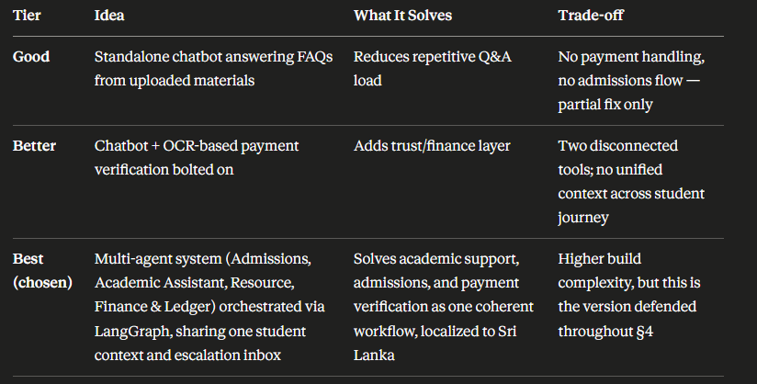

Axiom AI's final solution combines all four agents into a single tutor-facing assistant rather than separate point tools:

Admissions Agent : handles new student onboarding and PDPA-compliant consent capture.

Resource Agent : distributes papers/materials automatically on request.

Academic Assistant Agent : answers student questions using RAG grounded in the tutor's own uploaded material, not open internet knowledge.

Finance & Ledger Agent : OCR-reads payment slips, cross-checks against expected payments, flags anomalies, and issues digital receipts.

1.2 User Roles & Permissions

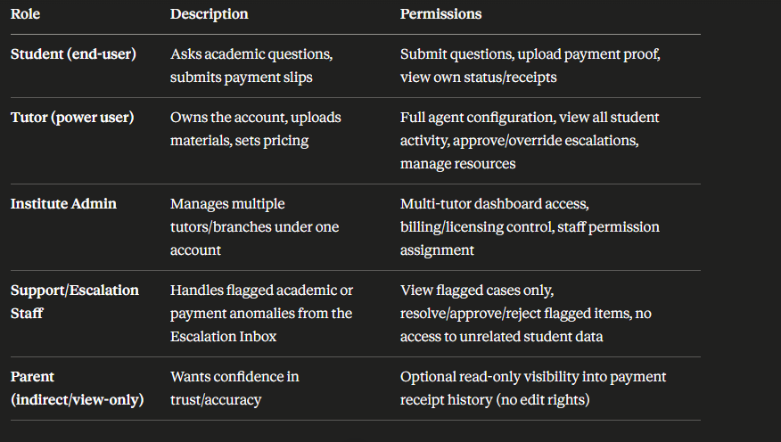
All four agents route ambiguous or flagged cases to a shared human Escalation Inbox, so no agent makes a final call alone on anything affecting money or academic accuracy.

Market Analysis

Market Context
Private tuition (“shadow education”) is a deeply embedded part of the Sri Lankan education system, spanning primary, O/Level, and A/Level students. Tutors and tuition institutes commonly manage anywhere from a few hundred to several thousand students each, almost entirely through unstructured WhatsApp and Telegram groups. This creates a large, recurring, and currently unaddressed operational burden: repetitive Q&A, manual paper distribution, and manual payment verification. Axiom AI targets this operational gap directly, rather than competing as “yet another EdTech app.”

1.2 Market Sizing (indicative)
Layer | Definition for Axiom AI
TAM (Total Addressable Market) | Total annual private tuition spend across Sri Lanka : all tutors, all subjects, all provinces.
SAM (Serviceable Available Market) | Tutors and tuition institutes with a large enough student base (indicatively 100+ students) to feel the WhatsApp/manual-payment pain acutely, and with smartphone/internet access to use a chat-based product.
SOM (Serviceable Obtainable Market) | Realistic first 12–18 month target: high-volume “star tutors” and small-to-mid tuition institutes in Colombo and the Western Province, expanding by district as word-of-mouth and case studies build.

Note: exact figures should be validated with published Department of Census & Statistics / education sector data before the meeting; the structure above is what to populate.

1.3 Customer Segments (Stakeholders)
- Solo “star tutors” : individual tutors managing 500–5,000+ students personally. Highest pain, fastest decision-maker, but price-sensitive as an individual buyer.
- Tuition institutes / academies : multiple tutors and subjects under one brand. Higher contract value, more stakeholders in the buying decision, need multi-tutor/multi-branch support.
- Parents (indirect) : not the primary buyer, but a key influence on trust : they need confidence the AI won't mishandle payments or give wrong academic answers.

1.4 Competitive Landscape
Competitor Type | Examples | Why Axiom AI Wins
Status quo (real incumbent) | Manual WhatsApp/Telegram groups + spreadsheets/notebooks | This is the actual competitor to beat. Axiom AI removes hours of repetitive manual work without asking the tutor or student to change platforms.
Generic chatbot builders | WATI, ManyChat, Twilio-based bots | These require the tutor to build and maintain flows themselves; no built-in academic RAG, no OCR payment verification, no LK-specific context.
LMS / classroom tools | Google Classroom, Moodle | Built for structured institutional courses, not the informal, high-volume, chat-first tuition model used in Sri Lanka.
International AI tutoring apps | Generic AI tutor products | Not localized to Sri Lankan bank slip formats, PDPA consent flow, exam boards, or a specific tutor's own teaching style.

1.5 Market Tailwinds
- Smartphone and WhatsApp penetration in Sri Lanka is already near-universal among students and parents : no new app download required.
- Rising tutor workloads and burnout from manual admin create urgency to adopt automation.
- Digital payment adoption (bank transfers, QR) is increasing, making OCR-based slip verification timely rather than premature.
- Low existing competition that is both AI-native and Sri Lanka-specific : a genuine first-mover window.

2. Product Branding
2.1 Brand Naming
Axiom AI: An axiom means a foundational statement or principle established as accepted, self-evident, or universally true (especially in mathematics, logic, and philosophy). For a tutor, this name signals accuracy, reliability, and mastery of core concepts to help with the fundamentals.

2.2 Brand Positioning Statement
For Sri Lankan tutors and tuition institutes who are overwhelmed by manual WhatsApp administration, Axiom AI is an AI-powered assistant that automates admissions, academic support, and payment verification : unlike generic chatbots or manual processes, Axiom AI understands the tutor's own teaching style and Sri Lanka's specific payment and compliance context.

2.3 Brand Pillars
Pillar | What It Means | Proof Point
Trust | Safe with money and data | OCR fraud/duplicate detection, PDPA-compliant consent capture, human escalation for anomalies
Always-on convenience | Support doesn't stop at class hours | 24/7 academic Q&A grounded in the tutor's own material
Personal | Feels like the tutor, not a generic bot | RAG answers reflect the specific tutor's methodology and tone
Local | Built for Sri Lanka, not adapted from elsewhere, can include local language support (Sinhala, Tamil) | Local bank slip formats, districts, exam boards, PDPA

2.4 Tone of Voice & Visual Direction
- Tone: warm and reassuring, not corporate : positioned as “your tutor's assistant,” never as a replacement for the tutor.
- Visual identity: should feel approachable to students/parents (friendly, education-adjacent) while still reading as credible/professional enough for institute-level buyers.
- Axiom is also a reference to Wall-E, maybe we can use the design elements/colours to mimic and create our interface

3. Suggestions for Business Models

3.1 Revenue Models Analysis
Model | How It Works | Trade-off
Per-tutor SaaS subscription | Tiered monthly fee based on student count/features | Predictable revenue and easy to forecast, but may deter price-sensitive solo tutors at entry
Per-institute / agency licensing | Flat or seat-based licence sold to tuition academies | Higher contract value per deal, but longer sales cycles and fewer total customers
Transaction-based fee | Small % or flat fee per payment verified through the Finance Agent | Scales naturally with usage and feels “fair,” but revenue is less predictable early on
Freemium | Free under a student-count threshold (e.g. 50), paid above it | Strong growth in customer base, but delays monetization and needs a clear upgrade trigger or feature/s to incentivize switching to paid
Hybrid (recommended) | Base subscription + transaction fee on payment verification | Balances predictable base revenue with usage-based upside; mirrors common fintech/POS pricing logic and scalable with userbase growth

3.2 Recommended Approach
Lead with the Hybrid model: a modest base subscription (tiered by active student count) that covers Admissions, Resource, and Academic Assistant agents, plus a small per-transaction fee on the Finance & Ledger Agent's payment verification. This lets the product be affordable to try, scales revenue in line with the value delivered (money verified, time saved), and gives a natural upsell path from freemium-style entry tiers into institute-level licensing.

3.3 Illustrative Pricing Tiers
Tier | Target Customer | Includes
Starter (Free / low-cost) | Solo tutors, <50 students | Admissions + Resource Agent, limited Academic Assistant queries/month
Growth | Solo tutors / small institutes, 50–500 students | Full Academic Assistant + Finance Agent (transaction fee applies), CRM dashboard
Institute | Multi-tutor academies, 500+ students | Multi-branch/multi-tutor support, escalation inbox, priority support, custom onboarding

3.4 Unit Economics Considerations
- LLM inference cost (Gemini/OpenRouter/Cursor) per conversation should be modelled against subscription price per tutor to confirm gross margin at each tier.
- OCR/vision calls for payment slips are a variable cost that scales with successful adoption of the Finance Agent : factor this into the transaction fee, not just the subscription.
- Human escalation handling (staff time in the CRM) is a real cost center and should inform how aggressively edge cases are automated vs. routed to humans.

4. Defending the Solution

4.1 Objection Handling
Likely Objection | Response
“The AI will give wrong academic answers.” | The Academic Assistant Agent uses RAG grounded in the tutor's own uploaded materials and teaching methodology : it is not answering from open internet knowledge, which sharply limits hallucination risk. Complex or ambiguous queries route to a human via the Escalation Inbox.
“Parents/tutors won't trust AI with money.” | The Finance Agent doesn't auto-approve blindly : it OCR-reads the slip, cross-checks amount/date against expected payment, flags duplicates or mismatches, and routes anomalies to a human. Every verified payment produces a digital receipt/QR ticket, creating a clear audit trail.
“Tutors will lose the personal touch with students.” | Axiom AI is positioned to absorb repetitive admin and FAQ load, freeing the tutor's own time for actual teaching and higher-value student interaction : it is framed as the tutor's assistant, not a replacement.
“This is just a wrapper around ChatGPT.” | The value is in the orchestration: multi-agent routing (LangGraph), Sri Lanka-specific context (PDPA consent, local bank slip formats, district/exam board data), tutor-specific RAG grounding, and CRM-integrated human escalation : none of which a generic chatbot subscription provides out of the box.
“What happens if the AI is wrong about a payment and a student is blocked from class?” | Ambiguous or flagged cases are never auto-rejected silently : they route to the human Escalation Inbox for manual review before any access decision is made.
“Why would a tutor pay for this instead of continuing on free WhatsApp?” | Frame the cost against hours currently spent on manual Q&A, grading, and payment chasing : the product is priced to be cheaper than the tutor's own time at scale, not competing with WhatsApp as a messaging tool.

4.2 Structured Defense Framework (Needs → Solution → Value)
For any objection raised in the meeting, structure the response using five linked elements from the IIBA Core Competency Model:
- Need : What specific problem or opportunity is this addressing? (e.g. manual admin doesn't scale past ~200 students)
- Stakeholder : Who is affected : tutor, student, parent, or institute admin : and what does each specifically need?
- Context : What makes this a Sri Lanka-specific problem (bank slip formats, PDPA, exam calendars) that generic tools don't solve?
- Value : What is it worth to that stakeholder : hours saved, fraud avoided, faster response, better retention?
- Change : What has to change in the tutor's or student's workflow, and how is that friction minimized?
Answering all five in sequence pre-empts most follow-up questions before they're asked.

4.3 Key Risks to Acknowledge Proactively
- Data privacy: PDPA compliance must be visibly built into the Admissions Agent's consent flow, not bolted on afterward.
- Payment fraud edge cases: the system should be explicit that duplicate/fraudulent slip detection reduces but does not eliminate risk : human review remains the final safeguard.
- Tutor dependency: positioning should avoid implying tutors become redundant : that framing invites resistance from the exact audience being sold to.

Competition (Detailed)

1. Direct WhatsApp-First AI Education Platforms
These platforms focus on placing the entire educational and operational workflow inside WhatsApp without forcing students/parents to download a separate app.
- Jessica AI (India)
  - What it does: A WhatsApp-native AI agent for educational institutes. It operates directly in WhatsApp, answering repetitive student/parent questions, verifying fees, sending timetables, and integrating with underlying systems.
  - Similarity to Axiom: Handles admission inquiries, student queries in plain language, and fee management without requiring an app download.
- Ojiva AI / Ominiflow (South Asia / India)
  - What it does: WhatsApp Business API platforms explicitly built for coaching institutes and schools. They handle the full applicant funnel, document collection via chat, automated payment reminders, and CRM escalation.
  - Similarity to Axiom: Focuses heavily on reducing administrative friction in the admissions and fee-collection funnel via messaging touchpoints.

2. Coaching & Tuition Institute Management SaaS
These platforms dominate the private tuition market in emerging markets by giving tutors white-labeled tools to manage thousands of students, fees, and content.
- Classplus (India / Global Expansion)
  - What it does: The largest SaaS builder for private tutors and coaching centers in Asia. It gives tutors a branded app to sell courses, track fees, distribute content, and communicate via chat.
  - Comparison: While Classplus uses native mobile apps, Axiom AI leverages WhatsApp/Telegram natively, reducing friction for students who avoid downloading new apps.
- Teachmint (Global / Emerging Markets)
  - What it does: An all-in-one education ERP and classroom platform for private tutors and schools. Handles fee collection, attendance, material sharing, and student communication.
  - Comparison: Teachmint offers strong administrative ERP tools, but Axiom AI focuses more heavily on conversational multi-agent automation (RAG doubts + OCR bank slip verification).
- SikGen AI
  - What it does: A white-label LMS built specifically for coaching centers that provides a RAG-grounded AI tutor trained on the institute's exact curriculum, alongside test series and student tracking.
  - Similarity to Axiom: Direct overlap with Axiom's Academic Assistant Agent (RAG study buddy using the tutor's specific voice and materials).

3. AI Doubt-Solvers & Academic Assistants
Platforms focused on the "Academic Assistant / RAG Study Buddy" feature.
- Filo & Doubtnut (South Asia)
  - What they do: Instant 24/7 doubt-clearing platforms where students snap photos of handwritten or printed questions to get instant AI solutions or video step-by-step explanations.
  - Comparison: Filo operates as a B2C platform, whereas Axiom AI allows the individual tutor to own the AI tutor, keeping responses aligned with their personal teaching methodology and syllabus.
- Khanmigo / Coursebox AI
  - What they do: AI pedagogical assistants that act as interactive Socratic tutors, helping students reason through problems step-by-step rather than just giving direct answers.

4. DIY / General WhatsApp Automation + OCR Stacks
Tutors who do not use a dedicated EdTech SaaS often assemble custom workflows using business automation tools:
- WATI / AiSensy / Interakt + Make.com / n8n
  - How they compare: Tuition centers use these WhatsApp Business API providers combined with webhook automation tools (n8n/Make) and OpenAI/Gemini Vision APIs to extract data from bank payment receipts.
  - Axiom AI’s Advantage: Axiom AI replaces this fragmented DIY stack with a pre-built, domain-specific multi-agent orchestrator (LangGraph), native Supabase/Qdrant vector search, and a built-in CRM escalation inbox.

Key Competitive Edge for Axiom AI
Feature / Domain | Standard SaaS (e.g., Classplus) | Generic WhatsApp Bots (e.g., WATI) | Axiom AI
User Interface | Separate mobile app required | WhatsApp / Telegram | WhatsApp / Telegram (Zero app install)
Payment Verification | Direct Gateway / UPI | Manual checking / basic webhooks | Multimodal Vision OCR for Bank Slips + Fraud Detection
Academic Q&A | Basic Q&A / static video links | Keyword scripts | LangGraph Multi-Agent RAG trained on Tutor Materials
Local Compliance | Generic global/regional standards | N/A | Local PDPA Compliance + LK Banking Slip OCR Optimization

Suggestions for this Sunday
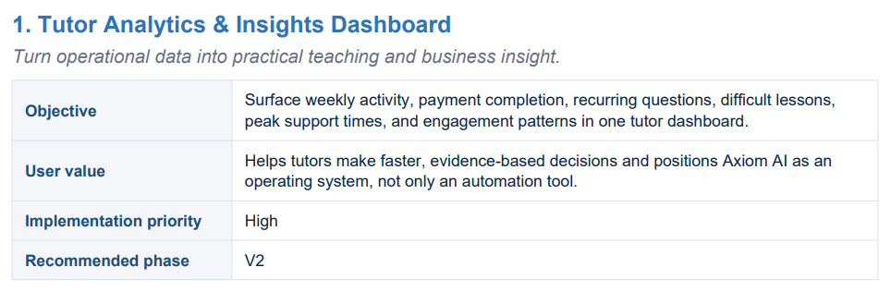

Customer Journey Map

